The cubit throughout the Bible

The cubit throughout the Bible does not always represent the same measurement unit. Some instances, like in Ezekiel are explicit and some like 2Ch 3:3 are not.

An handbreath is the width of four fingers pressed together (standardized to 3”) | 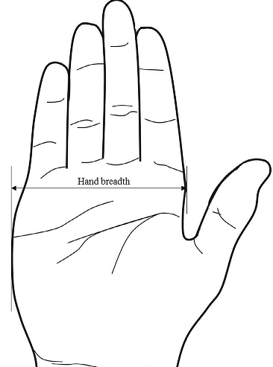

A span is the distance from thumb to pinky | 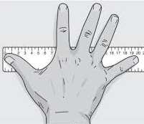

A (common) cubit is the distance from the elbow to the fingertip of a man | 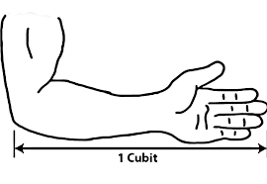

Reference | Notes | Common name | Handbreadths (3” each)
Gen 6:15 | First mention of “cubit”. The Ark. Built by men. | Very likely the common cubit* | 6*
Exo 25-27 | The Tabernacles dimensions. Built by men. | Common cubit | 6 (~18”)
Deu 3:11 | “after the cubit of a man” | Common cubit | 6
2Ch 3:3 (1Ki 6:2) | “after the first measure”  Solomon’s temple. Built by men. | Common cubit | 6
Eze 40:5 | “by the cubit and an hand breadth”  The future, millennial temple. Built by God and men (Zec 6:12,13,15). | Long cubit | 7
Eze 43:13 | “the cubit is a cubit and an hand breadth”. The future, millennial temple. | Long cubit | 7
Mat 6:27, Luke 12:25, John 21:8 | Jesus didn’t explicitly use the long cubit and the multitude used the common cubit. | Common cubit | 6
Rev 21:17 | “according to the measure of a man, that is, of the angel” (Mat 22:30, Mar 12:25, Luk 20:36) | Common cubit | 6

* Why the cubit for the Ark was very likely the common cubit:
- 2Ch 3:3 “after the first measure”
  - If there was more than “one measure” of the cubit before 2Ch 3:3 (chronologically) we would have no way of proving which one was the “first measure”. Thus, Deu 3:11 “after the cubit of a man” (and every other cubit before 2Ch 3:3) is the same as “the first measure”.
  - Until we get to Ezekiel where we are given the “long/royal” cubit which clearly states “by the [common] cubit and an handbreath”. If “the cubit” was anything but the common cubit before Ezekiel, then Ezekiel’s “long/royal” cubit would be instead 8 handbreadths which doesn’t make sense.

Notes:
- The Siloam (Shiloah; Isa 8:6, Luk 13:4, Joh 9:7,11; H7975, G4611) inscription (Hezekiah’s tunnel; ~2700yrs ago) reads “...and there flowed the waters from the spring to the pool for a thousand two hundred cubits…”. That distance has been measured in modern times to be 1,750 feet.
    - 1750 / 1200 = 1.4583
    - 1.4583 x 12 = 17.5 inches (per cubit)
      - Remember, we don’t know exactly where the builders of Hezekiah’s tunnel began and ended their measurement and that there was roughly 2700 years of erosion between the two measurements.
      - 17.5in. x 1200cu. = 21,000in.
      - 18in. X 1200cu. = 21,600in.
        - The difference between using a 18in. cubit and using a 17.5in. cubit is 2.77%

